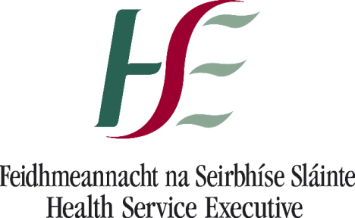Mental Health Division

Health Service Executive

Oak House

Limetree Avenue

Millennium Park

Naas

Co Kildare

Tel: 045 880400

29th September 2016

Deputy Gerry Adams

Dail Eireann

Leinster House

Dublin 2

**PQ 25594/16 - \*** * **To ask the Minister for Health further to Parliamentary Question Number 202 of 26 May 2016, the Programme for Government funding that has or will be committed in 2016 to address priority long waiters; and the way this is intended to impact on waiting times in County Louth. - Gerry Adams**.

Dear Deputy Adams,

The Health Service Executive has been requested to reply directly to you in the context of the above Parliamentary Question, which was submitted to the Minister for Health for response.

Please find in the table below the detail of the Programme for Government once-off funding allocation to the National Counselling Service nationally in 2016 to provide for those waiting longer than 6 months.

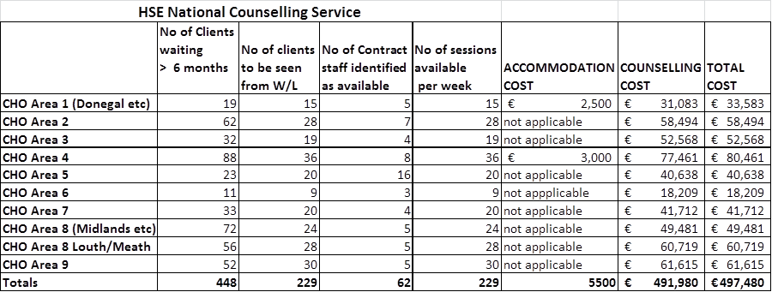

The funding for CHO 8 for Louth/Meath is intended to provide counselling to those clients who have been waiting for counselling with the NCS in CHO 8 Louth/Meath 10 months or more where it is identified that a medium term counselling contract is appropriate to their needs.

As a result counselling has been offered to 28 clients who have been waiting more than 10 months in Louth/Meath. Specifically for Co. Louth this means that 14 clients will be offered counselling contracts and the effective waiting time for ongoing counselling will reduce from 13 months to 10 months.

I trust this information is of assistance to you.

Yours sincerely



_____________

Carol Ivory

Planning Performance and Programme Management

Mental Health Services